RESTAURANT BILLING SYSTEM
Major Project (MCA 465)
Degree

MASTER OF COMPUTER APPLICATION

PROJECT GUIDE:  Dr.Priyank Singhal | SUBMITTED BY:  Mohd Nadeem (TCA2063046) Archit Bansal(TCA2063019)


MAY, 2022

COLLEGE OF COMPUTING SCIENCES AND INFORMATION TECHNOLOGY TEERTHANKER MAHAVEER UNIVERSITY, MORADABAD

Table of Contents
- Project Title 4
- Domain 4
- Problem Statement 4
- Project Description 4
  - Scope of the Work 5
  - Project Modules 6
- Implementation Methodology 6
- Technologies to be used...........................................................................7 6.1 Software Platform 7
  - Hardware Platform 7
  - Tools 8
- Advantage of this Project 8
- Future Scope and Further enrichment of the Project 10
9 Conclusion………………………………………………………... 31

DECLARATION

We hereby declare that this Project Report titled RESTAURANT BILLING SYSTEM
Submitted by us and approved by our project guide, to the College of Computing Sciences and Information Technology (CCSIT), Teerthanker Mahaveer University, Moradabad, is a Bonafide work undertaken by us and it is not submitted to any other University or Institution for the award of any degree diploma / certificate or published any time before.

Project Group
Student Name | Archit Bansal | Signature
Student Name | Mohd Nadeem | Signature
Project Guide | Dr.Priyank Singhal | Signature

Project Title

RESTAURANT BILLING SYSTEM

Domain: Restaurant Application (Python GUI based Restaurant Application)

Objective:
The main goal of this software programmer is to create an automated Working Condition. This device is based of the idea the any task in the System required the use of a guide. The following goals will be served by this mission.
• To upload and save information about the next menu.
• To save and update worker information.
• To upload and save the outline of a completely new menu.
• To provide the owner with a perspective on the purchase.
• To provide a practical solution for billing trends.
• To create user-friendly settings.
• An easy-to-use device

Domain

Desktop Application

Problem Statement
You are buying a subscription to a news website. This application will allow you to read news about any country that you want, it does not require an internet connection to operate, and it is very easy to use. Besides providing you with the necessary information about the country you want to read about, this program also allows you to keep track of all the other news that's happening in the world.

Project Description

The restaurant Billing System is a System Based Invoice system with a User helpful interface that manages the customer's Invoice Method automatically and efficiently.
Eatery Charging Framework might be a System Based charging framework with a user helpful

Connection that automated monitors of the client's charging handle in a brief amount of time. The system can process huge large amounts of data while also calculating the charge for the client. RBS can also be used to obtain charging history, reservation data, and employee data. It's computerized desktop-based computer software with a straightforward layout and is also really simple to use. The correct management of data concerning the personnel, charging, and reservation records are at the heart of this project. It is also skilled in preparing client bills and discounts a result of this. The suggested framework either does not require printed content or just requires extremely modest paper works. All of the data is rapidly entered into the System Based, and many Invoices could be created using System. No information is lost because everything is stored in a database.

Scope of the Work

The computer program encompasses a part of highlights and focal points over the article-founded charging framework It has the taking after scopes This extend will offer the assistance the representative with quick billing. The venture will empower you to see free reservations available. Quality and faster service could be given to the customers. Easy of the
Preserve in prospect this venture empowers workers to preserve

Project Modules

Registration

The data that users provide in the system is required to be registered in order to perform the necessary transactions. For instance, if a bill is issued, the name of the bill will be shown. There are also various other things that we can reference him.

Login
After enrolling, you can log in to the system as the system's operator. Either under the user's name or on behalf of the customer. Following that, he gets access to the additional user interfaces for further actions.

Select Item
We have had the option of selecting the stuff we need to eat from this menu. On-demand, we may search using various filters such as food flavor based on rating, feedback, drinks, fast food, continental, state-by-state, healthy food, compliments, and so on. From here, you can choose depending on filters such as price, just added, a particular dish, and much more.
He can also select more than he wants and add it added to his accounts in a highly user-friendly interface.

Bill

Now, a bill of sale will be developed based on the items selected, and it will be presented. The tax calculations also are taken into consideration here, and this record is exceeded directly to the whole calculation. The invoice is then supplied to the user, observed via way of means of the fee area.

Payment

Now, a bill of purchase will be developed based on the selected items, and it will be presented to the user. The tax calculation is likewise positioned into the account here, and this record is then exceeded directly to the entire calculation, and then the invoice is exhibited to the user,
Accompanied through the coins desk.

Technology to be used

Hardware and Software Requirement

Hardware Platform

Processor : Intel Core Duo 2.0 Ghz or more
- RAM : 2GB or more

Hard Disk : 80GB or more
- Keyboard : Normal or Multimedia
- Mouse : Compatible Mouse

Software Platform
- PyCharm

Internet
- Operating System : windows 7,8,8.1,10
- SQLite 3 Database

Advantages of this Project

Create Invoices Instantly
Creating invoices is time-consuming; invoicing software program makes it faster by permitting customers to quick-adjust templates in only some clicks. Creating invoices takes time; invoicing software makes it easier by allowing clients to quickly adjust templates with just a few clicks.
Build and Save Custom Diagram
Some of your customers can also additionally have specific codecs and records required for the system fee. If your bill does ‟t provide them what they want the primary time, the fee could be not on time till those issues are resolved. Certain billing software program answers will let you create custom templates for those clients and keep them so that you are always imparting invoices in the correct layout for a short and easy fee.

Automatize Communications
As noted above, your organization is answerable for ensuring debts to you does ‟t slip via the cracks; however, that’s now no longer clean if you have such a lot of invoices to track. Invoicing software program solves this difficulty for you while you could automate price reminder letters, statements, and past-due notices so that you by no means neglect to permit clients to recognize their price closing date is coming near or that they're overdue. Sometimes an e-mail isn't sufficient and a phone name can be required. Some computerized billing structures offer the delivered gain of mechanically updating your calendar to remind you of approximately follow-up calls primarily based totally on the regulations you've got defined.

Provide Accurate Information
How antique is the data you’re operating off of today? In many cases, corporations that aren't the usage of billing software programs depend upon ageing reviews and spreadsheets which require guide updates. The billing software that's linked to your accounting or ERP machine is regularly updated so that you're no longer contacting clients about bills they've previously paid, operating off of outdated facts, or wasting time re-keying details when you could be doing something more important.

Data Flow Diagram (DFD) of Restaurant Billing System

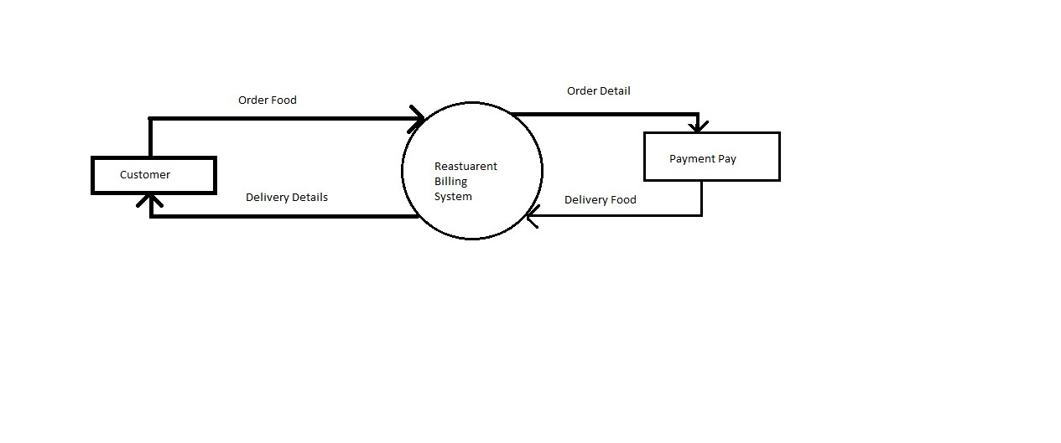

Customer
Order for the
food
Food Ordering
System
Food Order
Receipt
Bill
Restaurant Manager
Kitchen

Coding Screenshot

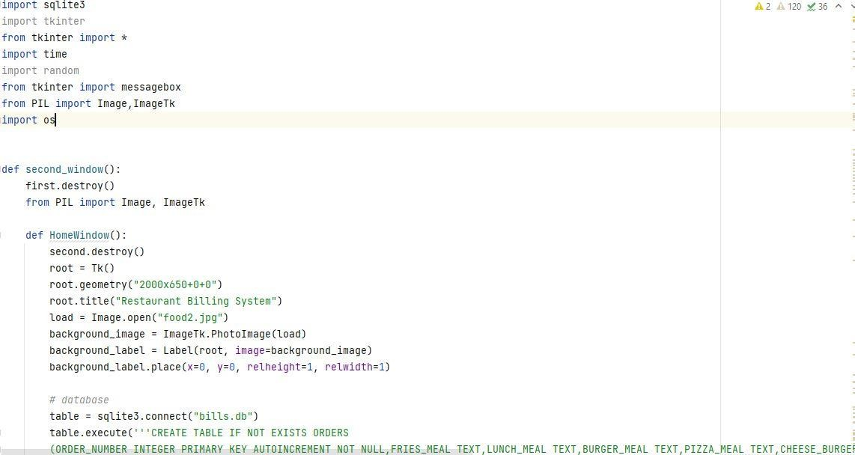

Database Code

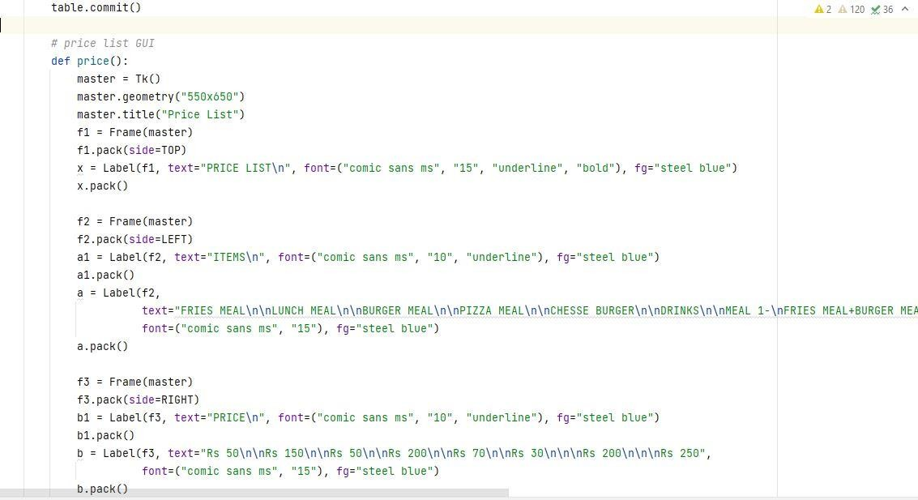

Price List GUI code

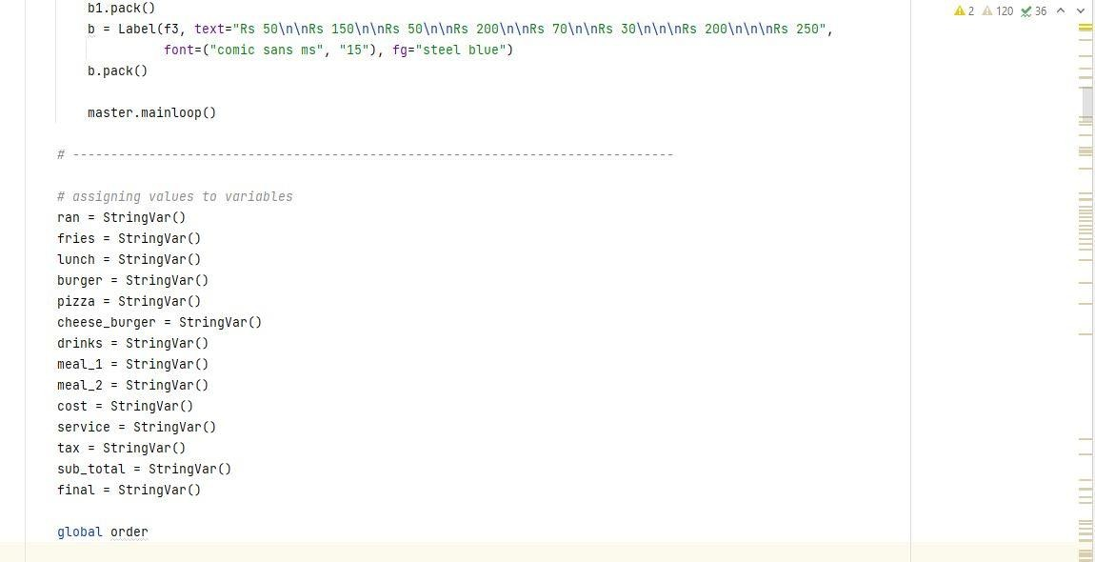

Assigning value code

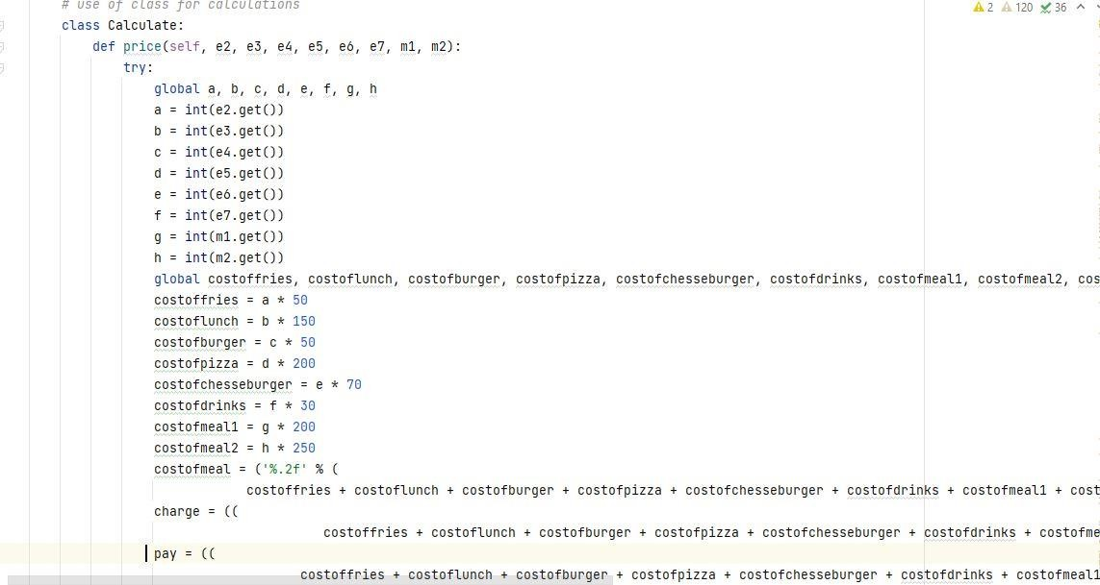

Calculation code

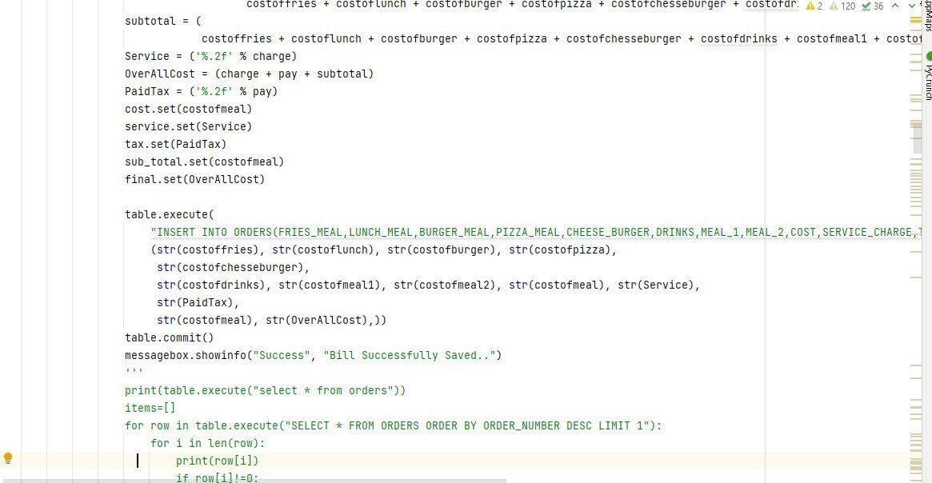

Calculation code

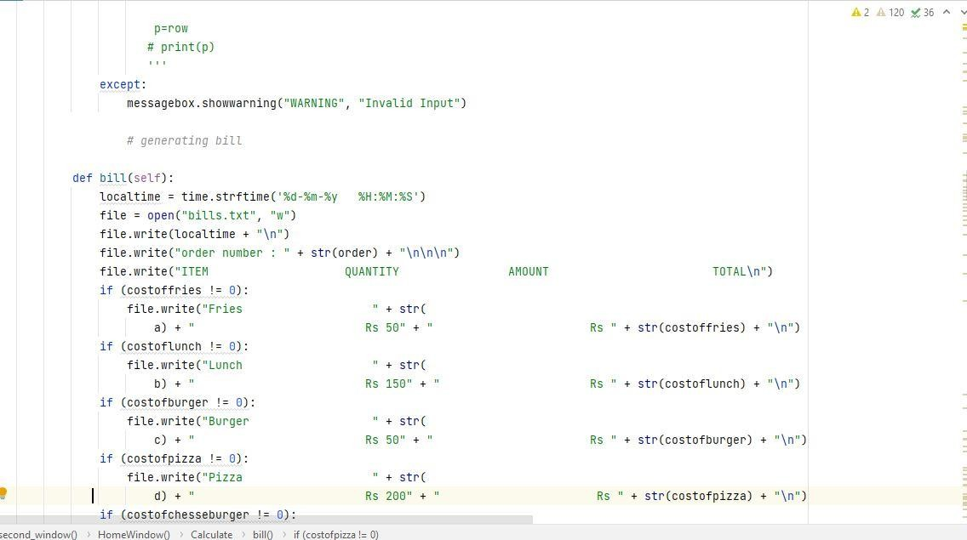

Calculation code

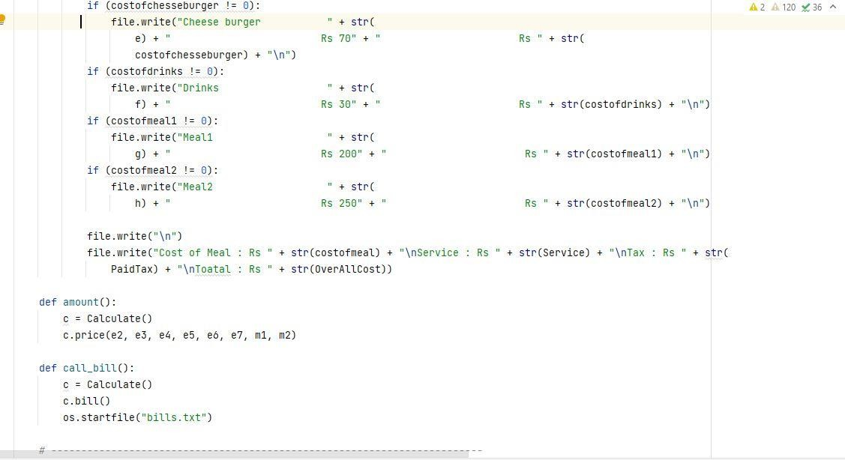

Calculation code

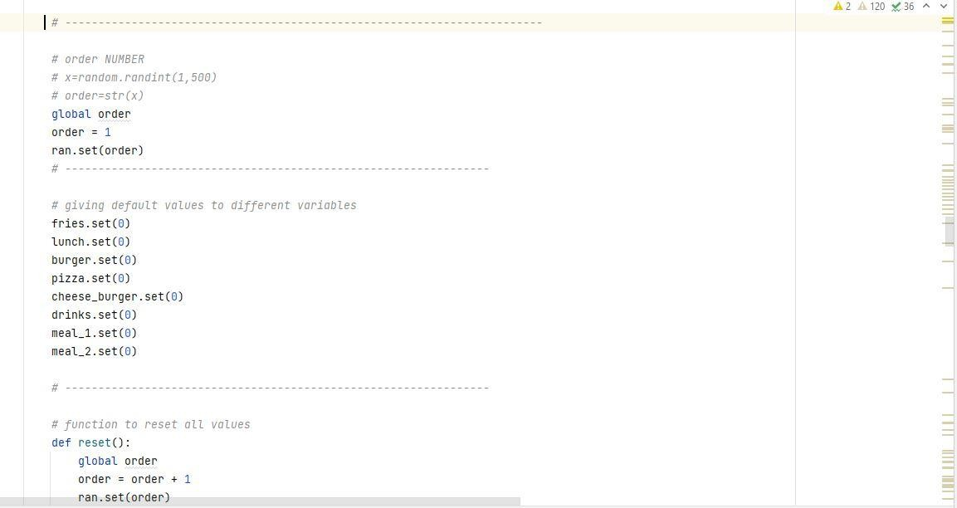

Order No code

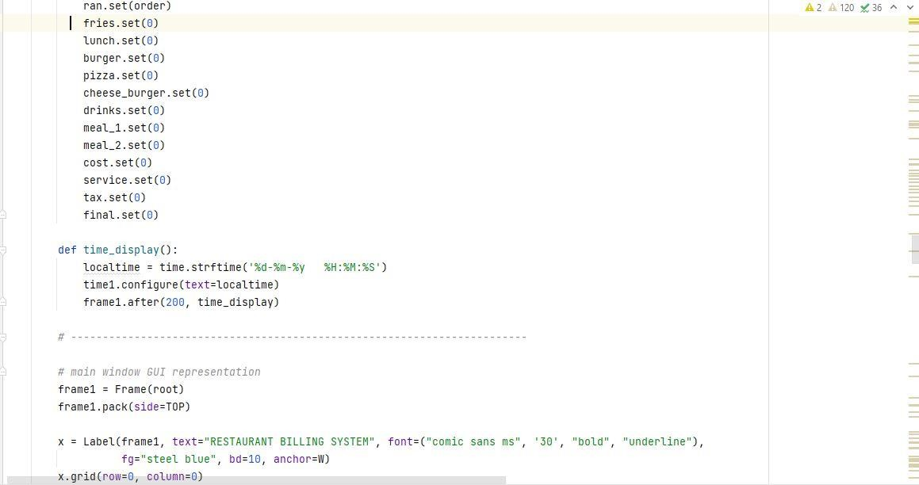

Main Window GUI Code

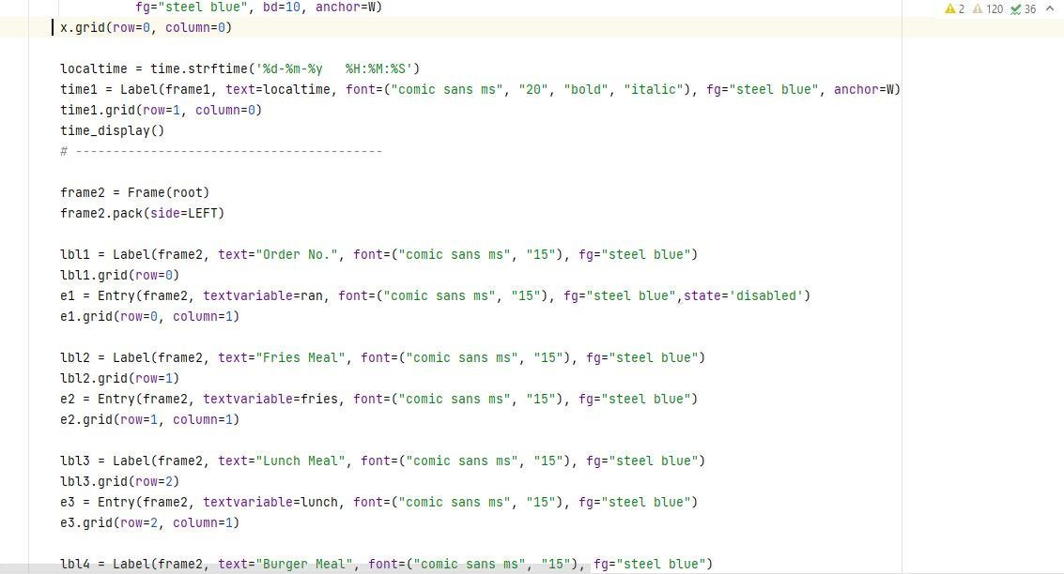

Main Window GUI Code

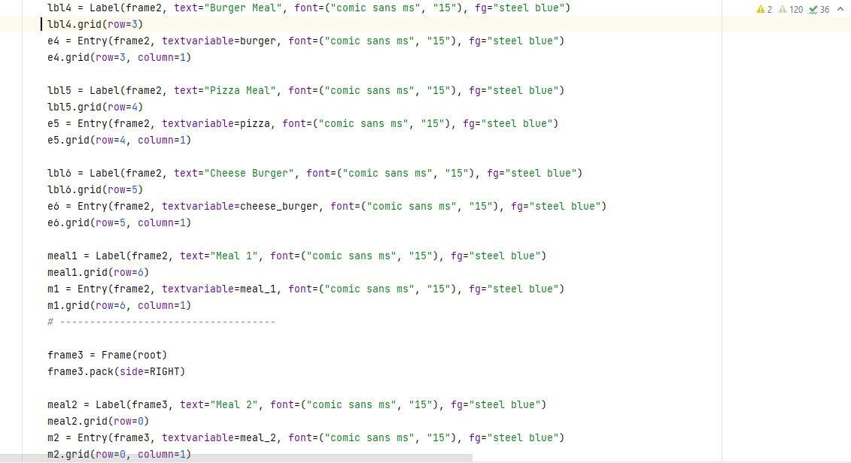

Main Window GUI Code

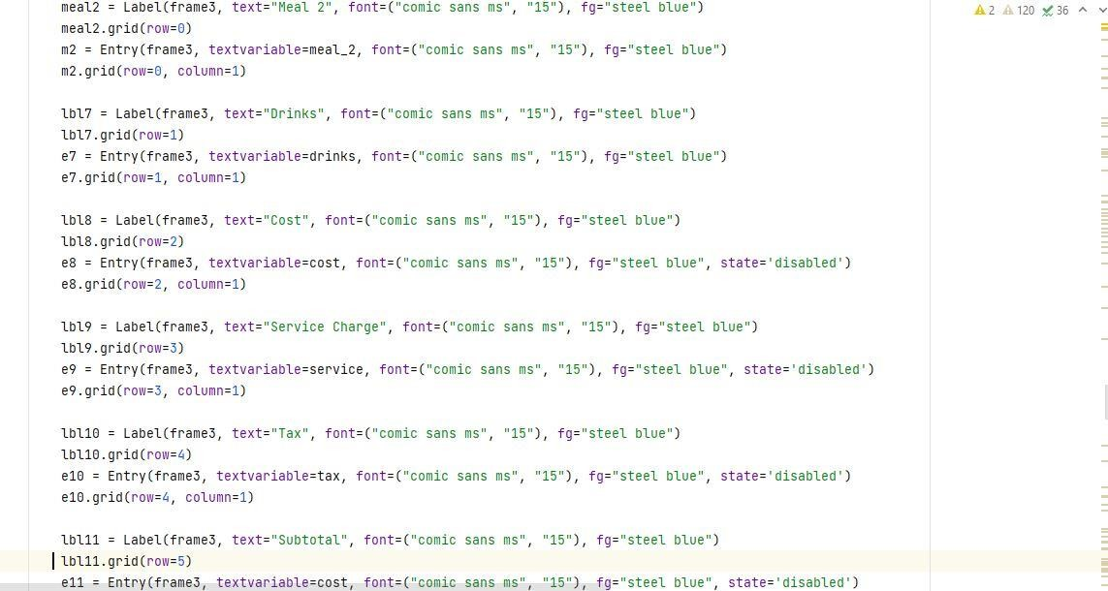

Main Window GUI Code

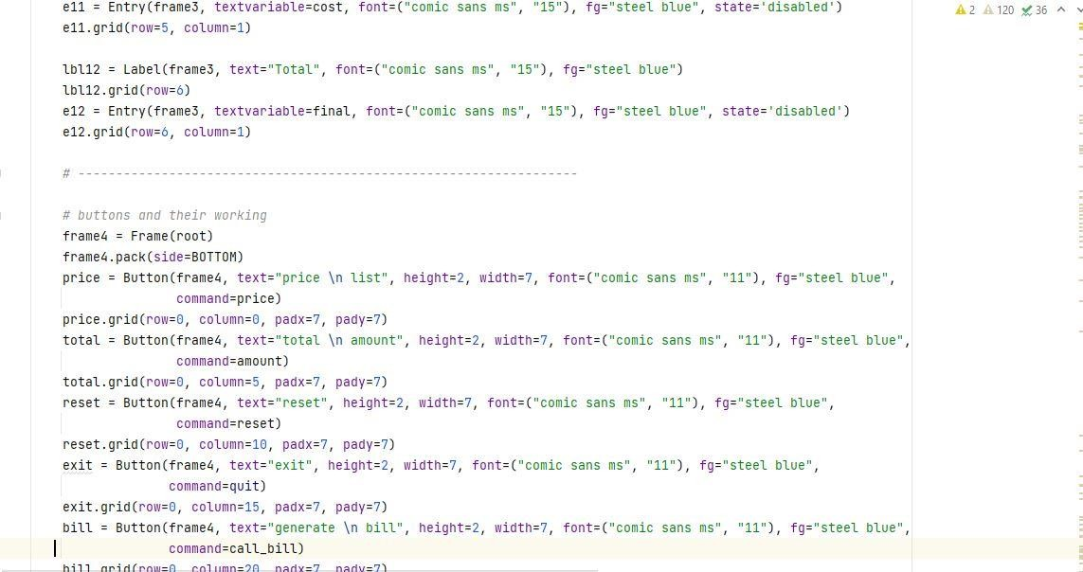

Button Code

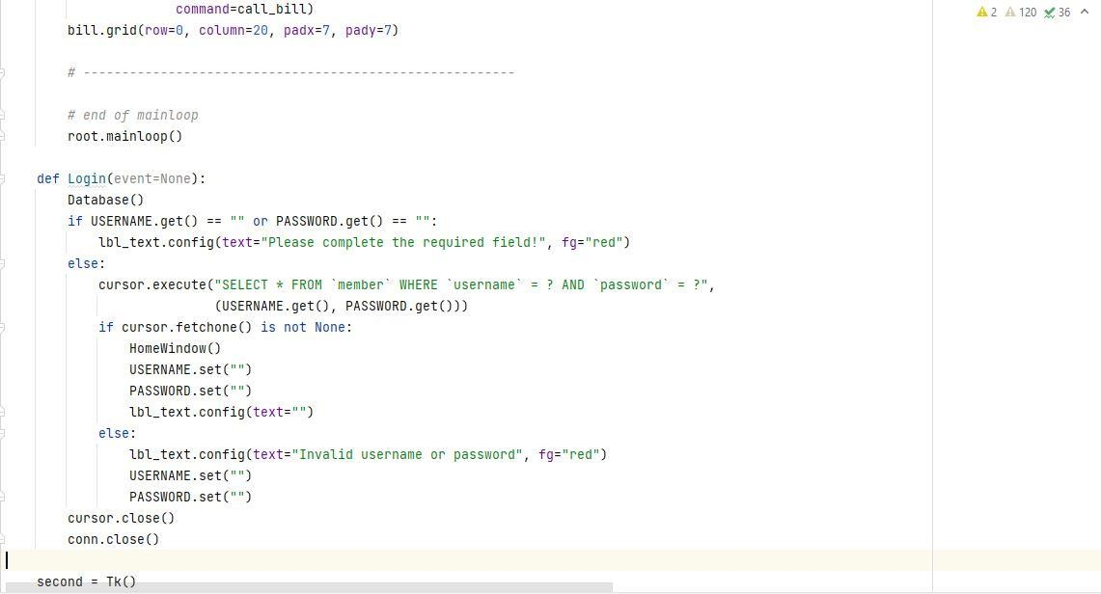

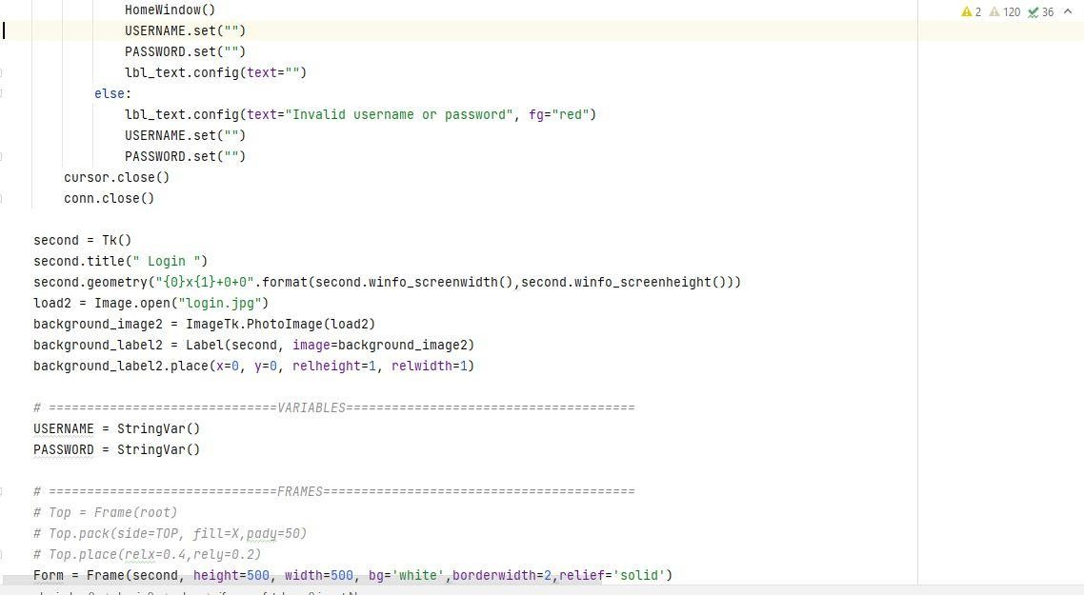

Frame Code

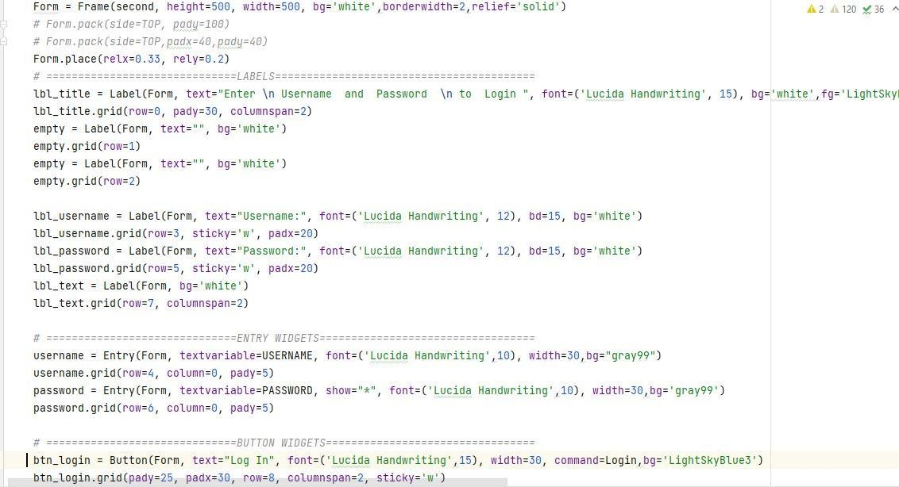

Labels Code

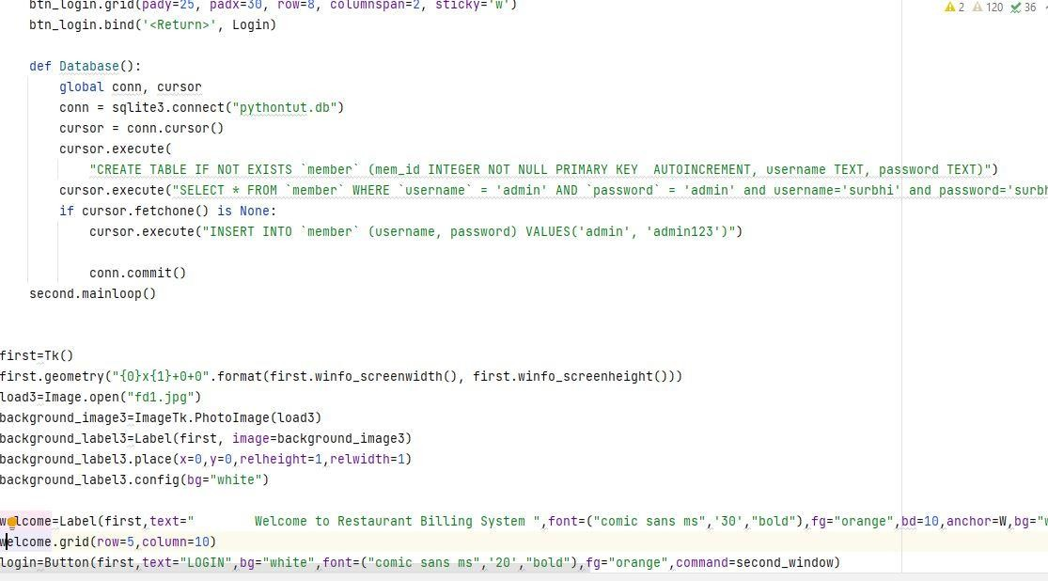
Submitted By Mohd Nadeem (TCA2063046)

Welcome Window

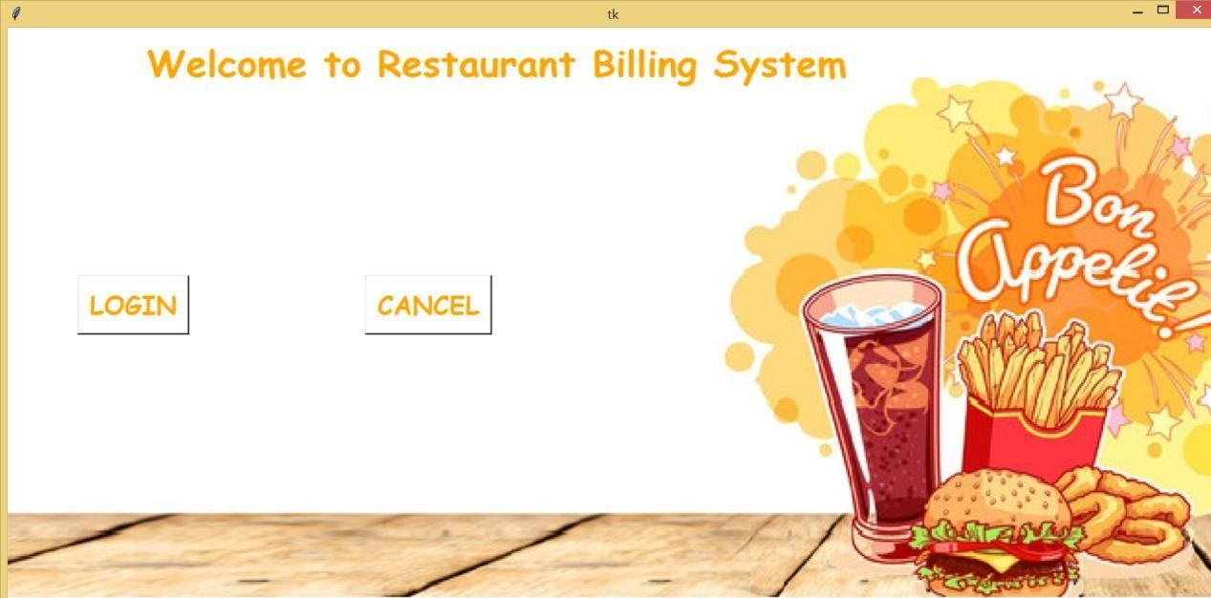

In this welcome window, there are two buttons.
  - LOGIN -Clicking this button will open another interface for login.
  - CANCEL - Clicking this button will close this window.

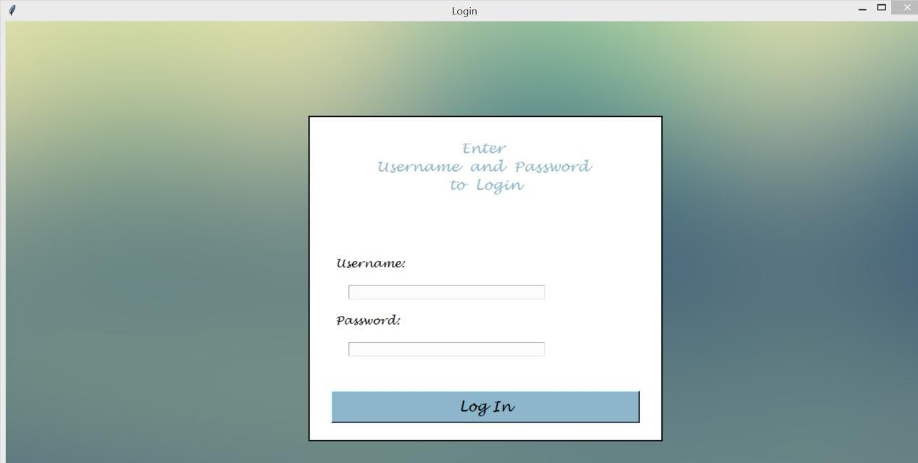

Login Form

In this Login Window, I has to enter the correct username of the Password to log in. I have linked three usernames and passwords for login in with the database. Currently, only these usernames and passwords will help you to log in. I will work for sign up where users can enter/her username and password and link it to a database in my further version.
Clicking login with incomplete information will show an error as follows:

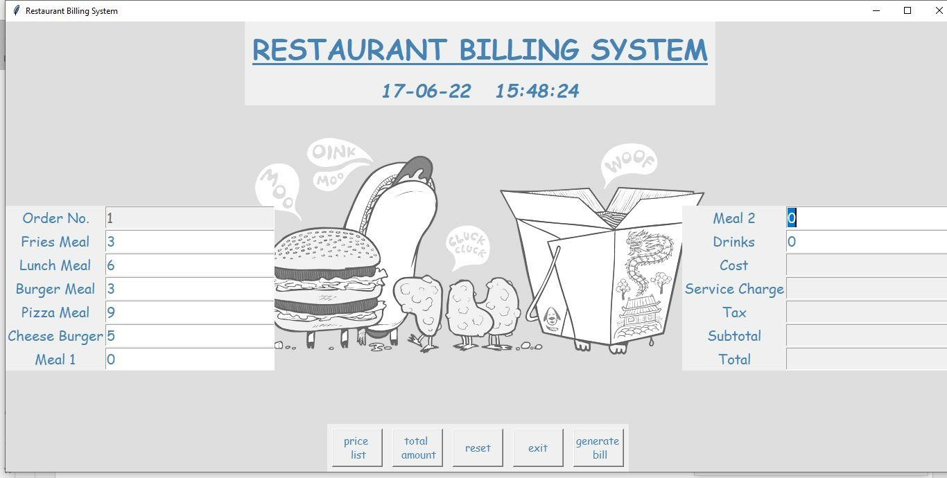

Menu
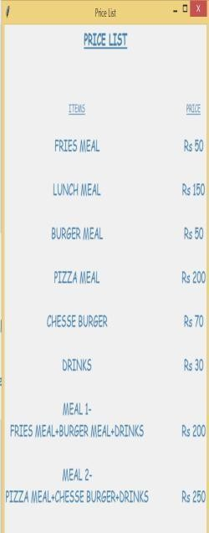
This main window displays the current system date and time on top. User has to enter quantities required for the food item and click the total amount button for getting the total amount and simultaneously saving it in the database with a pop-up message box.
Price List Window

Clicking on the price list button will open this price list window. This price list displays the prices of the menu offered. This program has a prespecified menu with their prices.

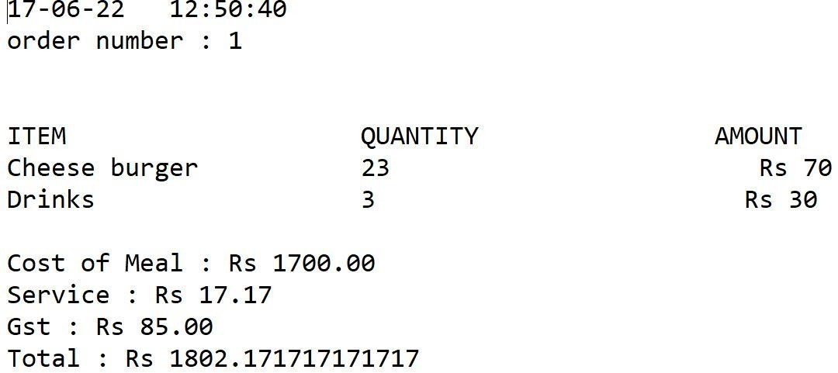

Generated Bill
Clicking on generating bill button in the main window generates a bill in the text document.

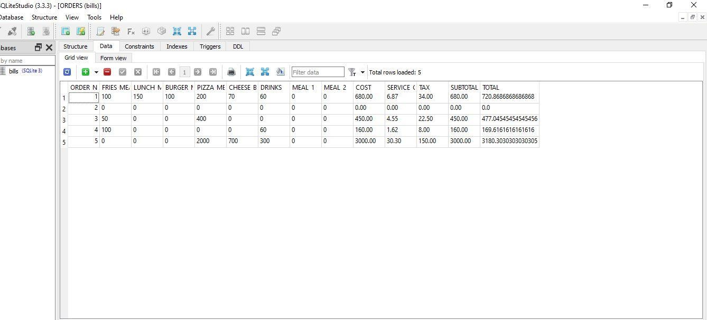

Database
TCA2063046
TCA2063019
Submitted By Mohd Nadeem
Archit Bansal

Page 30

Clicking on the total amount button in the main window will create a database table if not created in the same folder with the “bills. DB” name and extension. In this database Created order number is a primary key and will never be null and auto increment after every insertion

Conclusion
Finally, within the building charge system ASCII text file, the end result of all the time labor is here. We’ve got a system that takes the required decisions of the client in line with the assorted filters like worth, class of the food, and recognition. Then he will place the order consequently then the system calculates the entire order with taxes then it will dispatch the bill that's two-handed over to the client.
Customers in line with the selection pay the bill via money or positive identification or MasterCard methodology. Thus all the method works good, full filling the system

References:
  - https://acadview.com/

  - https://docs.python.org/3/

  - https://stackoverflow.com/

  - https://www.tutorialspoint.com/python3/

  - https://www.tutorialspoint.com/python/python_gui_programming.htm

  - https://www.geeksforgeeks.org/python-gui-tkinter

  - https://docs.python.org/2/library/tkinter.html
Submitted By Mohd Nadeem (TCA2063046)
Archit Bansal (TCA2063019) Page 31

